Matplotlib Exercises

Reference Link to be explored for animations: https://colab.research.google.com/github/phoebe-project/phoebe2-docs/blob/2.1/tutorials/animations.ipynb

1. Draw a line as shown below (value in y axis are thrice the value in x-axis ). Add a suitable label in the x axis, y axis and a title. 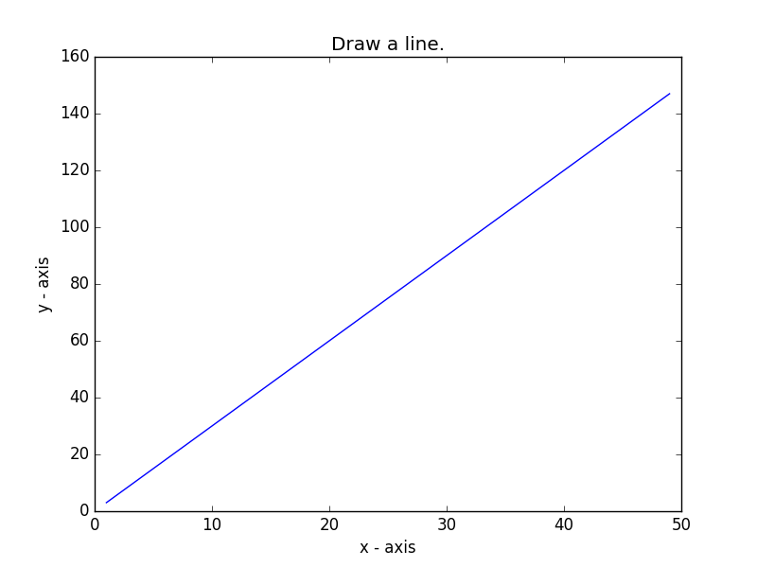
2. Write a Python program to draw following output-  
   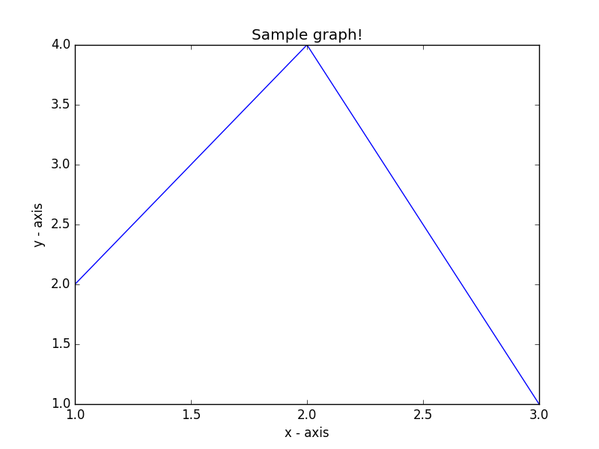

1. Write a Python program to display the grid and draw line charts of the closing value of ABC Ltd. between October 3, 2019 to October 7, 2019. Customized the grid lines with linestyle -, width .5. and color blue.   
   Date,Close  
   03-10-16,772.559998  
   04-10-16,776.429993  
   05-10-16,776.469971  
   06-10-16,776.859985  
   07-10-16,775.080017  
   The code snippet gives the output shown in the following screenshot:  
     
   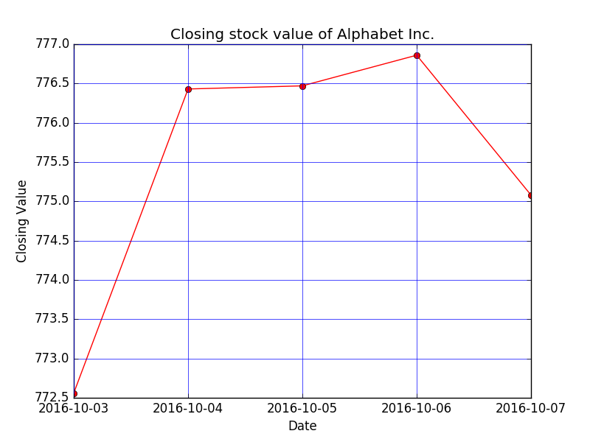
2. Plot two lines as shown below with appropriate legends, different widths and colors.   
   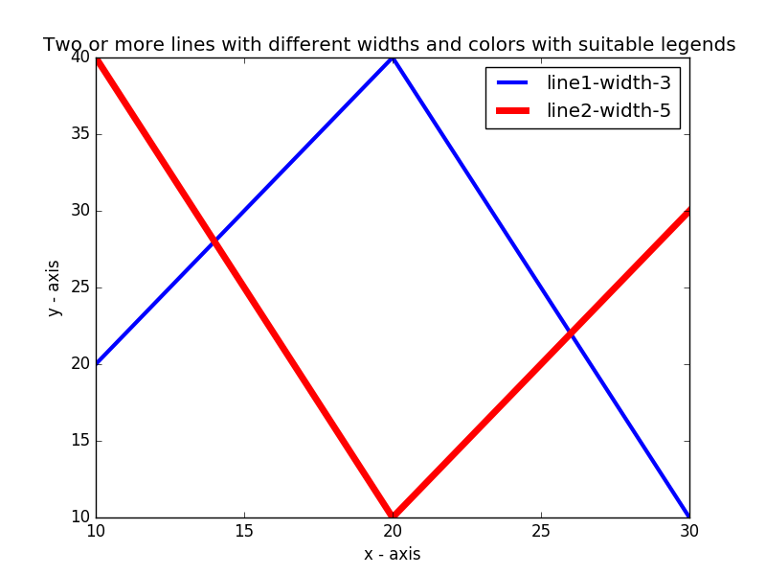
3. Display a bar chart of the popularity of programming Languages.  Attach a text label above each bar displaying its popularity (float value). Use different color for each bar. Make blue border to each bar.  
   Sample data:  
   Programming languages: Java, Python, PHP, JavaScript, C#, C++  
   Popularity: 22.2, 17.6, 8.8, 8, 7.7, 6.7
4. Convert bar chart of Q5 into horizontal bar chart and increase its bottom margin.
5. Create bar plot of scores by group and gender. Use multiple X values on the same chart for men and women.  
   Means (men) = (22, 30, 35, 35, 26)  
   Means (women) = (25, 32, 30, 35, 29)  
   Output should be as follows:  
   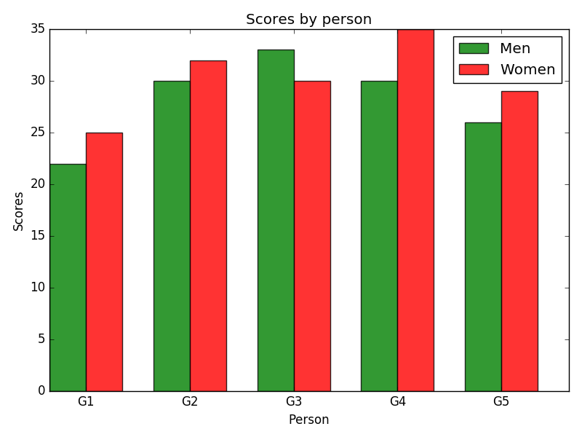
6. Write a Python program to create stack bar plot and add label to each section.   
   Sample data:  
   people = ('G1','G2','G3','G4','G5','G6','G7','G8')  
   segments = 4  
   # multi-dimensional data  
   data = [[ 3.40022085, 7.70632498, 6.4097905, 10.51648577, 7.5330039, 7.1123587, 12.77792868, 3.44773477],  
   [ 11.24811149, 5.03778215, 6.65808464, 12.32220677, 7.45964195, 6.79685302, 7.24578743, 3.69371847],  
   [ 3.94253354, 4.74763549, 11.73529246, 4.6465543, 12.9952182, 4.63832778, 11.16849999, 8.56883433],  
   [ 4.24409799, 12.71746612, 11.3772169, 9.00514257, 10.47084185, 10.97567589, 3.98287652, 8.80552122]]  
     
   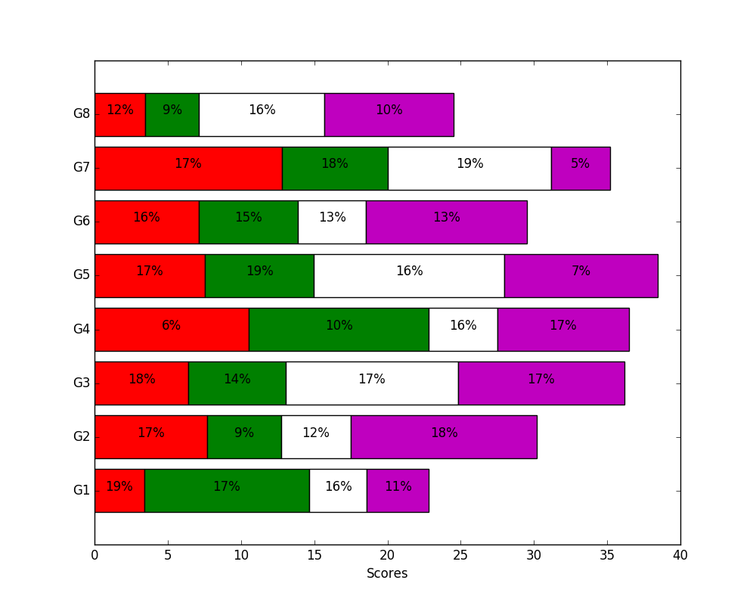
7. Create a pie chart of the popularity of programming Languages. Add a title to this pie chart. Use sample data given in Q5.
8. Create a pie chart of gold medal achievements of five most successful countries in 2016 Summer Olympics. Read the data from a csv file.   
   Sample data:  
   **medal.csv**  
   country,gold_medal  
   United States,46  
   Great Britain,27  
   China,26  
   Russia,19  
   Germany,17
9. Write a Python program to draw a scatter graph taking a random distribution in X and Y and plotted against each other.

